**Solution of Honey Yummy**

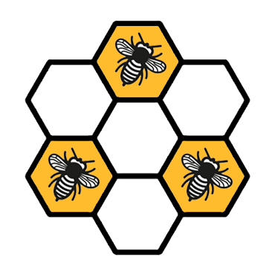

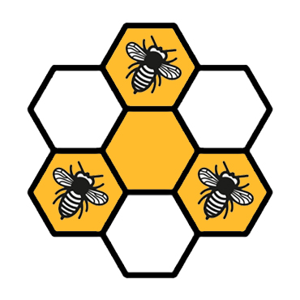

When there are three units around another unit are improved, the perimeter in number of edges of improved units will not be change when another unit improve. Since the number of unit on a edge of the hive is N, there the perimeter is (N+1)*6 in number of edges of the whole hive (all units), also that each single unit that not adjacent to others has a perimeter of 6 in number of edges, it has to put N+1 bees at least initially.

**Solution of A+B problem**

$$1/a+1/b=1/c$$

$$ab/a+ab/b=ab/c$$

$$b+a=ab/c$$

$$c(a+b)=ab$$

Let $a=rx$ and $b=tx$, where $x=gcd(a,b)$

$$c(rx+tx)=rtx^{2}$$

$$rx+tx=\frac{rt}{c}x^{2}$$

$$r+t=\frac{rt}{c}x$$

When $x=\frac{c}{rt}(r+t)$, the equation holds. Since when $gcd(r,t)=1$, $gcd(rt,r+t)=1$ always holds; therefore, the problem has became for how many positive integer pairs $(r,t)$ that are relatively prime to each other, $rt$ is a factor of $c$.

Let $\prod_{i=1}^{k}{p[i]q[i]}$, where $p[i]$ are distinct prime factors of $c$. It can be seem that for each prime factor $p[i]$, since $r$ and $t$ are relatively prime to each other, there must be several $p[i]$, positively zero, be either factors of $r$ or $t$. Since $c$ has at most $q[i]$ number of $p[i]$, there $r$ can have number of factor $p[i]$ from $1$ to $q[i]$, $t$ can have either number of factor $p[i]$ from 1 to $q[i]$, or both $r$ and $t$ have no factor of $p[i].$ In total, there are $q[i]∗2+1$ situations for each $p[i]$.

Thus we get the answer to problem, $\prod_{i=1}^{k}{(q[i]∗2+1)}$

Proof of when $gcd(r,t)=1$, $gcd(rt,r+t)=1$ always holds:

Let $gcd(p,t)=1$, where $p$ is a prime number

$gcd(rp,t)=1$ holds

$gcd(rt∗p,t+rp)≠$ 1 only when $t+rp$ is a multiple of $r$ or $p$. We know that $rp$ is a multiple of $r$ and $p$; therefore $t$ has also be a multiple of $r$ or $p$. And since, $gcd(r,t)=1$ and $gcd(p,t)=1$, it conflicts with the previous condition. Thus, when $gcd(r,t)=1$, $gcd(rt,r+t)=1$ always holds.